**Eon**

**Temperature Control System - Den**

**Use Case Report**

***Revision History***

|  |  |  |  |  |
| --- | --- | --- | --- | --- |
| **Authors** | **Description of Change** | **Sections** | **Rev** | **Date** |
|  |  |  |  |  |
|  |  |  |  |  |

**Table of Contents**

1 Team Description 4

2 Project Description 4

2.1 Use Case Diagram 5

2.2 Use Case List 6

2.2.1 Setting Temperature - Regular 6

2.2.2 Setting Temperature - City of Choice 6

# **Team Description**

|  |  |
| --- | --- |
| **Team Member Name** | **Email Address** |
| Erine Estrella | erine.double@gmail.com |
| Mohamed Jaafar | mohamedjaafar95@csu.fullerton.edu |
| Devontae Reid | devontae.reid@gmail.com |
| Sean Wulwick | sean.wulwick@csu.fullerton.edu |
|  |  |
|  |  |

# **Project Description**

Statement of Purpose:

This project serves as a Temperature Control System, allowing the user maintain their room’s temperature according to input.

Detailed Description:

A heating/cooling control system that is capable of taking user input and activating an HVAC system. This system also allows for scheduling and a external temperature display based on location information that is collected from the weather channel API. The control system is also capable of maintaining an climate within a room at a predefined threshold.

## **Use Case Diagram**

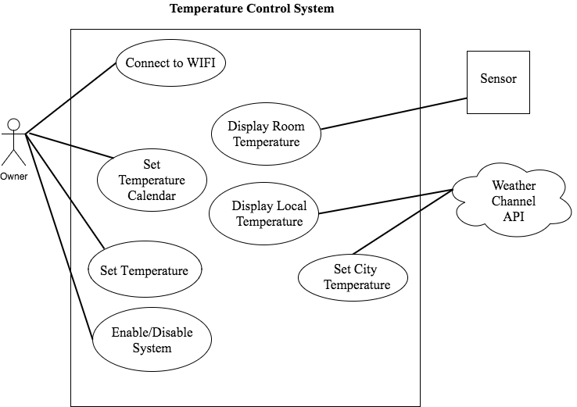

## **Use Case List**

|  |  |  |
| --- | --- | --- |
| **Use Case** | | |
| **Sequence Number** | **Actor** | **Goal** |
| 1 | User | Interacts with the GUI to request temperature change in a room. |
| 2 | Sensor | Reads temperature of an area and sends the data to the system. |
| 3 | Weather Channel API | Sends local weather information data to the system. |
| 4 | HVAC System | When the system sends a signal to this system the heating/cooling system is activated adjusting the temperature of the overall room. |
| 5 | GUI | Takes the data from the sensor and the Weather channel API and displays in an easy to read format for the user. |
| 6 |  |  |

### **Connecting to Wifi**

Primary Actor: Owner

Goal in Context: Giving the system access to the home wifi enables the use of the Weather Channel API integration.

Preconditions: System must be powered on.

Additional Description: This is more of a setup step than anything, most issues that arise here are based on the connection to the users wifi.

#### Connection Made

1. User taps the connect to wifi button.
2. List of nearby wifi connections is listed.
3. User selects desired wifi connection.
4. Display prompts user for password to wifi.
5. User correctly inputs password.
6. System connects to wifi.

#### Desired Connection Unavailable

1. User taps the connect to wifi button.
2. List of nearby wifi connections is listed.
3. Users desired wifi is not displayed.
4. Check personal router to ensure wifi connection is available.

#### No Connections Available

1. User taps the connect to wifi button.
2. List of nearby wifi connections does not display anything, simple text stating no wifi.
3. Reset system and try again.
4. If still no connections in list call customer assistance.

### **Setting Temperature**

Primary Actor: Owner

Goal in Context: User would like set room temperature to their own specified temperature.

Preconditions: System must be on, sensor must be functional.

Additional Description: The user is able to set the room to a requested temperature that will be displayed and will be kept up to date using the temperature sensor within the room.

#### Set Temperature

1. User presses display to activate.
2. User presses arrows under internal temperature read out.
3. System displays temperature equal to current internal temperature under current internal temperature.
4. Using the arrows to the left and right of this read out the user sets the read out to requested temperature.
5. System will kick on when requested temperature has not changed within 5 seconds.
6. When heating/cooling is completed and requested temperature is achieved system will turn off HVAC system.
7. If the temperature moves outside of 5 degrees within 5 minutes of the system turning off the system will turn back on to maintain the requested temperature. (This feature can be modified or disabled within the settings menu).

#### Sensor Error/HVAC error

1. If system has been active for 30 minutes with no significant change to room temperature system will turn off the HVAC.
2. System will then display an error stating there is an issue with ether the sensor or the HVAC system and to call customer support.

### **Setting Temperature - City Choice**

Primary Actor: Owner

Goal in Context: User would like set room temperature to one that matches a certain location temperature.

Preconditions: System must be on, internet access.

Additional Description: The user must be able to choose a temperature of choice depending on an accurate weather report of a city of their choice. For example, if the user lives in Los Angeles, CA, where it’s currently 84 F, the user might choose to set the room temperature to that of Manhattan, NY, where its 51 F.

#### Set Temperature According to City

1. User touches the display in order to start the system up.
2. System displays current temperature, along with any additional information.
3. User chooses to search for a city by entering zip code.
4. User enters 10002 as input.
5. System display weather report for Manhattan, NY and asks user to confirm choice.
6. Temperature is set to 51 degrees and maintained.

#### City Not Found

1. User touches the display in order to start the system up.
2. System displays current temperature, along with any additional information.
3. User chooses to search for a city by entering zip code.
4. User enters 00000 as input.
5. System is unable to detect city that corresponds to zip code enters.
6. User is informed of such error and asked to re-enter input.
7. User finally enters valid input.
8. Temperature is set accordingly.

### **Setting Temperature - Calendar**

Primary Actor: Owner

Goal in Context: User would like set room temperature to a desired temperature at a given time on any given day.

Preconditions: System must be on.

Additional Description: This must be set up prior to the event, this will then become a recurring event every week until cancelled or changed. This is also able to be disabled by the user using the vacation option in the system.

#### Set Temperature Event

1. User accesses the calendar on the system.
2. User presses the desired day of the event.
3. System will display a options box with times and a seperate options box with temperatures.
4. User will select time and temperature.
5. User will press confirm button.
6. System will then monitor time and temperature, if the temperature during that time on that day of the week does not match the system will activate and cool/heat the dwelling.

#### Delete Temperature Event

1. User presses the calendar on the system.
2. User presses delete option on display.
3. User selects day of requested deletion.
4. If there is only one the event will be deleted without any other window.
5. If there are multiple events set on the given day system will display them in a list.
6. User selects the requested deleted event.
7. System prompts user for confirmation displaying the temperature and time of the event.
8. If correct the user selects the confirm option.
9. If incorrect the user will select cancel.
10. System will reset to list view.
11. Once confirmed or if it was the only event system returns to main display, brief text box stating event deleted.

### **Activating Vacation Mode**

Primary Actor: Owner

Goal in Context: User wants to disable system and all events for an unspecified amount of time.

Preconditions: System must be on.

Additional Description: This is a simple user interface button allowing for instant disabling of all events and disables the connection the HVAC system to disallow accidental activation.

#### Enable

1. User activates display.
2. User presses the blue airplane button.
3. Airplane button turns red.

#### Disable

1. User activates display.
2. User presses the red airplane button.
3. Airplane button turns blue.